

**Operation Manual**

**Spare Part Control System**

(Version 0.02)



* Please read this manual carefully before operation.
* The following screenshots may vary in different operating system.

Purpose of the manual

Thank you for using this software. This manual is a guide for proper operation of this software. Please keep this manual safely for your future reference.

Attention

Assurance provision separately stipulated is valid only in Malaysia and Singapore as the specification of this software is for the use of these countries.

Copyrights

Copyrights related to this operation manual and this software are exclusively belonging to Panasonic System Networks Malaysia Sdn. Bhd. All rights reserved for entire description in this manual regardless of form and means except when Panasonic System Networks Malaysia Sdn. Bhd. approves in advance.

**Important!**  You may not give, copy, disassemble, decompile, reverse engineering and export in violation of prohibition on export, for a software included in this system. Panasonic System Networks Malaysia Sdn. Bhd. will not take any responsibility on mistakes and flaw in this operation manual even though it has meticulously been created.

If you may have noticed any unclear and incorrect points related to the description in this operation manual, kindly let us know.

Please note that the information in this operation manual may change without prior notice.

Trademarks

* Microsoft and Excel are either registered trademarks or trademarks of Microsoft Corporation in the United States, Japan and other countries.
* Other described companies and products are either registered trademarks or trademarks of respective companies.

Target Readers

Target of this manual is the user of Spare Part Control System.

Glossary

* **Spare Part Control System** or **SPS** is a system that efficiently tracks and manages parts in and out of a facility.
* **Users** refer to personnel who have been given the authority to login to the SPS. There are two types of users: administrator and basic, which have different access right to the graphical user interface (GUI).
* **Character** refers to the American Standard Code for Information Interchange (ASCII) character-encoding scheme which originally based on the English alphabet.
* **Digit** refers to the 10 symbols of the common base-10 number system which is 0 to 9.

*Index*

1.0 Login **5**

2.0 Forgot Password **6**

3.0 Main Menu **7**

4.0 Miscellaneous **8**

4.1 General **8**

4.2 Email **9**

5.0 User **10**

5.1 Add **10**

5.2 Detail **11**

6.1 Edit **12**

6.2 Delete **12**

7. Maintenance **13**

7.1 Building **13**

7.1.1 Add **13**

7.1.2 Detail **13**

7.1.3 Edit **14**

7.1.4 Delete **14**

7.2 Rack **15**

7.2.1 Add **15**

7.2.2 Detail **15**

7.2.3 Edit **16**

7.2.4 Delete **16**

7.3 Part **17**

7.3.1 Add **17**

7.3.2 Detail **18**

7.3.3 Edit **19**

7.3.4 Delete **19**

8.0 Report **20**

8.1 In/Out **20**

8.2 Inventory **21**

8.3 Log **22**

9.0 In/Out Record **23**

9.1 Record **23**

9.1.1 Type – In or Out **23**

9.1.2 Save Information **24**

9.2 Import **25**

1. 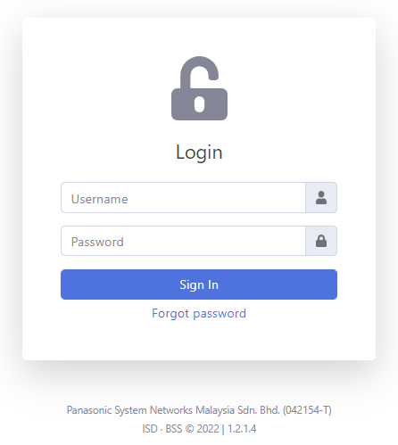Login

* The user is required login before using the system.
* Note:
* Kindly ask the system admin to register the user before using the system.

1. Forgot Password

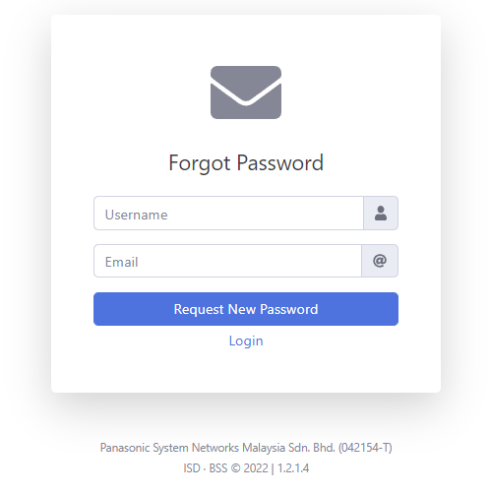

* The user can request new password by entering username and email address.
* Note:
* The user must register their email address to the system in order to receive a link of reset password.

1. Main Menu

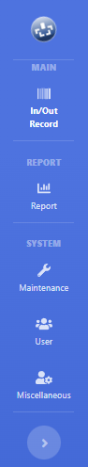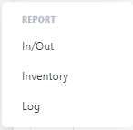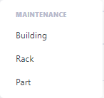

* The main menu consists of main, report and system.
* Note:
* The size of the menu can be adjusted by clicking button.

1. Miscellaneous

* This function consists of general and email that allows the user to modify the setting of the system.
  1. General

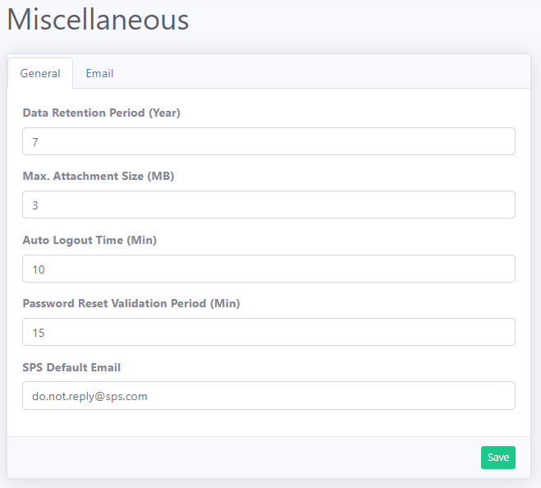

* General information regarding the system setting is located here.

|  |  |  |  |  |  |
| --- | --- | --- | --- | --- | --- |
| **Function** | Data Retention Period (Year) | Max. Attachment Size (MB) | Auto Logout Time (Min) | Password Reset Validation Period (Min) | SPS Default Email |
| **Default** | 7 | 3 | 10 | 15 | do.not.reply@sps.com |
| **Min/Max** | 1-10 | 1-10 | 5-15 | 5-15 | - |
| **Remark** | How many years the date is keep in the system | Max size allowed for part image storage | User will be forced to logout after idle | Email link expiry that is send to the user | Email name display when sending a message to user |

* 1. Email

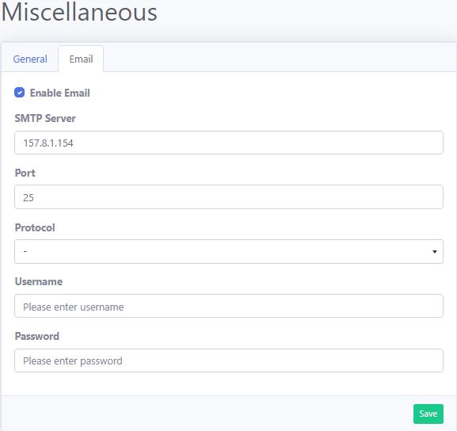

* Email information regarding the system setting is located here.

|  |  |  |  |  |  |  |
| --- | --- | --- | --- | --- | --- | --- |
| **Function** | Enable Email | SMTP Server | Port | Protocol | Username | Password |
| **Default** | - | - | - | - | - | - |
| **Remark** | Enable email function | Protocol for mail transmission | Identify a specific application on a computer | Method of communication channel | Username of the server | Password of the server |

1. User

* This function allows to add, edit and delete user from the system.
  1. Add

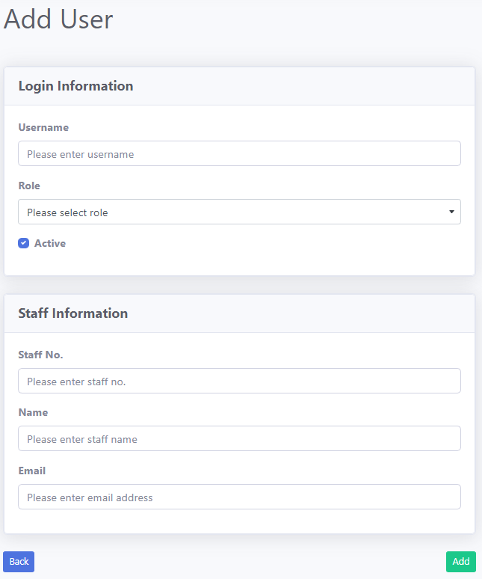

* The user needs to enter login and staff information in order to register a user to the system.
* Note:
* The entered email address is used to reset your login password.
* Username is used to login to the system.
  1. Detail

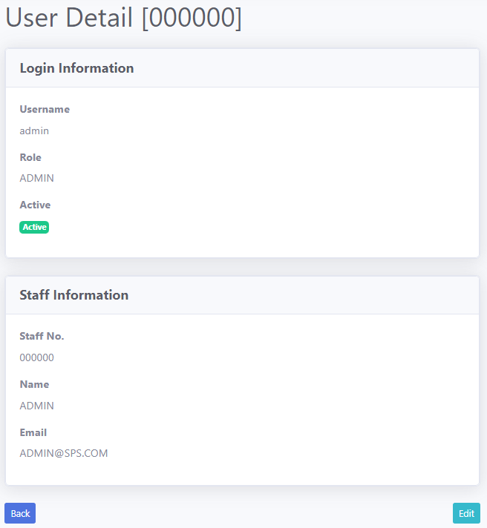

* This page display details regarding selected user information.
  1. Edit

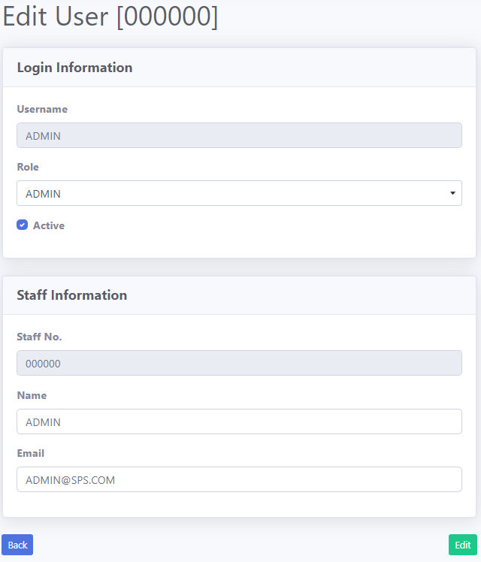

* The user can update the user information by modifying login or staff information.
* Note:
* Username and staff no. are not allowed to edit.
  1. Delete

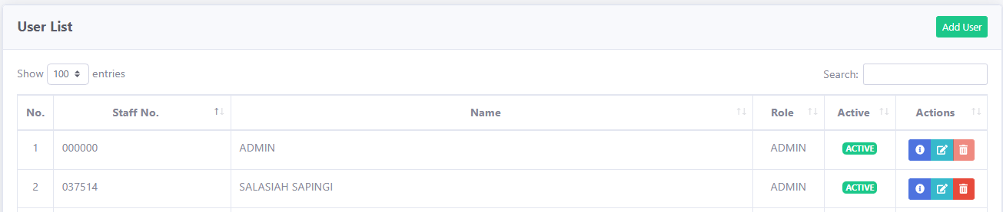

* The user can delete user information by clicking the trash button.
* Note:
* Admin is not allowed to delete.

1. Maintenance
   1. Building

* This function allows to add, edit and delete building/cabinet from the system.
  + 1. Add

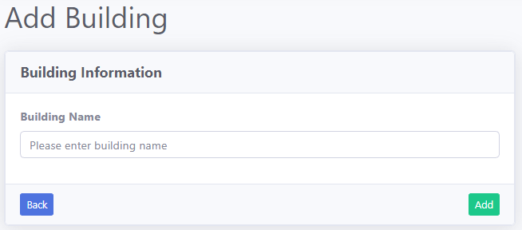

* The user needs to enter building information in order to register a building to the system.
  + 1. Detail

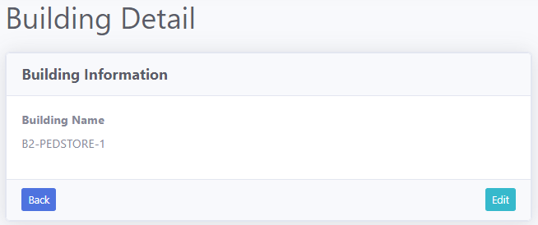

* This page display details regarding selected building information.
  + 1. Edit

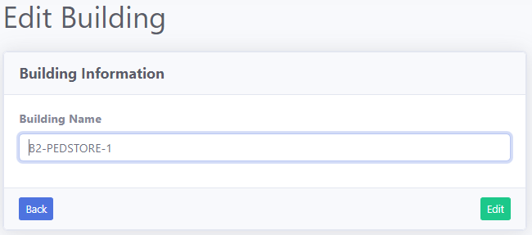

* The user can update the building information by modifying selected building.
  + 1. Delete

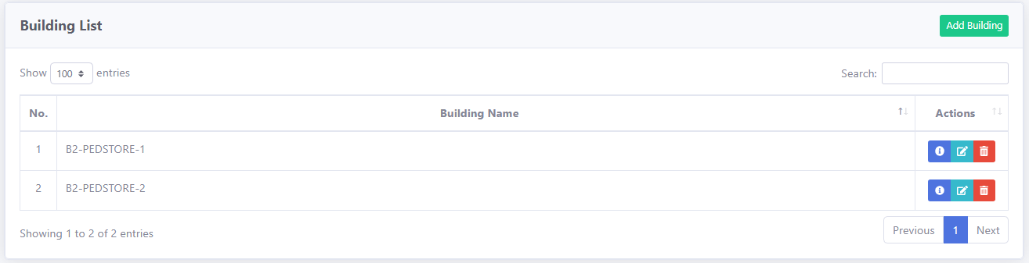

* The user can delete building information by clicking the trash button.
  1. Rack
* This function allows to add, edit and delete rack from the system.
  + 1. Add

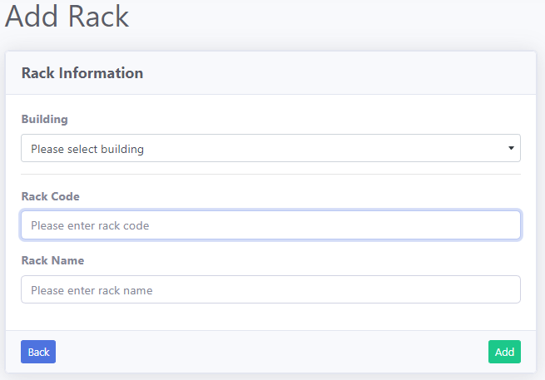

* The user needs to enter rack information in order to register a rack to the system.
  + 1. Detail

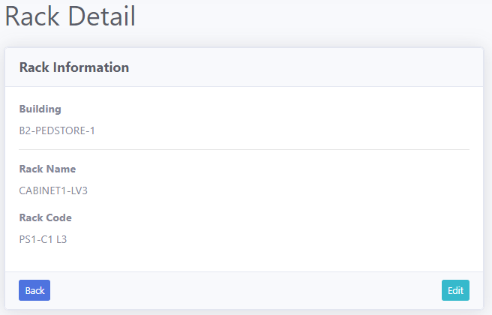

* This page display details regarding selected rack information.
  + 1. Edit

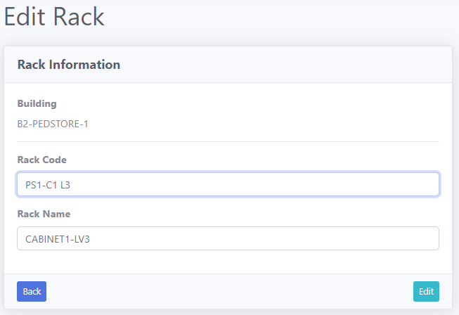

* The user can update the rack information by modifying selected rack.
  + 1. Delete

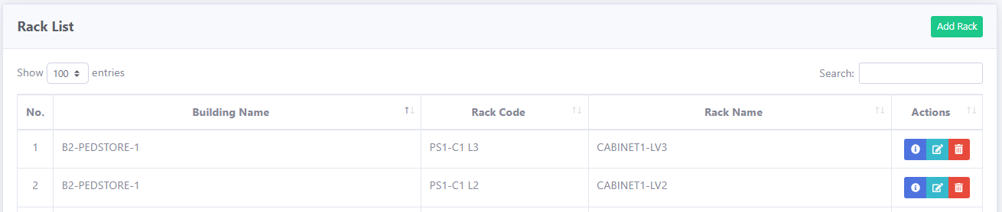

* The user can delete rack information by clicking the trash button.
  1. Part
* This function allows to add, edit and delete part from the system.
  + 1. Add

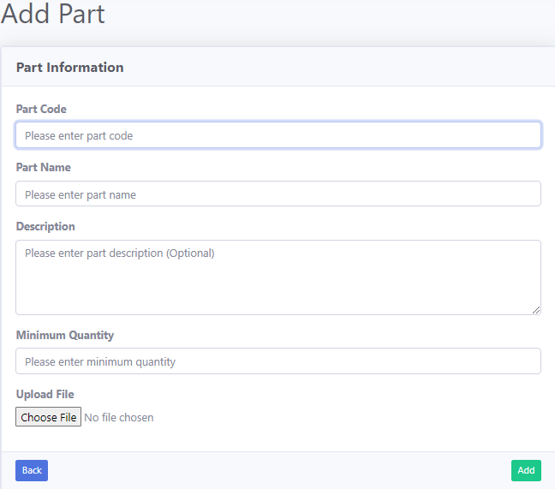

* The user needs to enter part information in order to register a part to the system.
  + 1. Detail

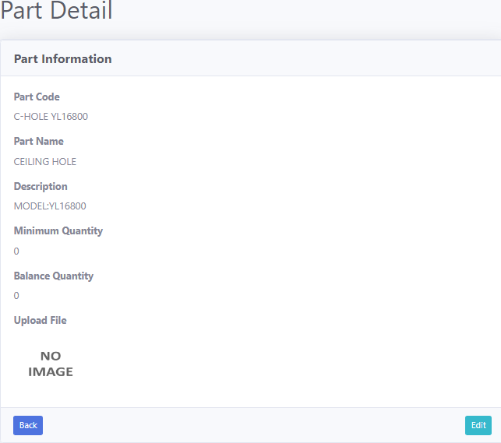

* This page display details regarding selected part information.
  + 1. Edit

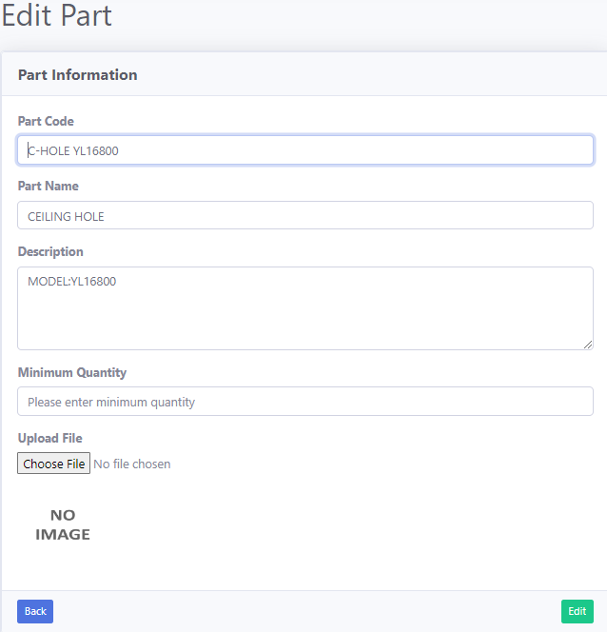

* The user can update the part information by modifying selected part.
  + 1. Delete

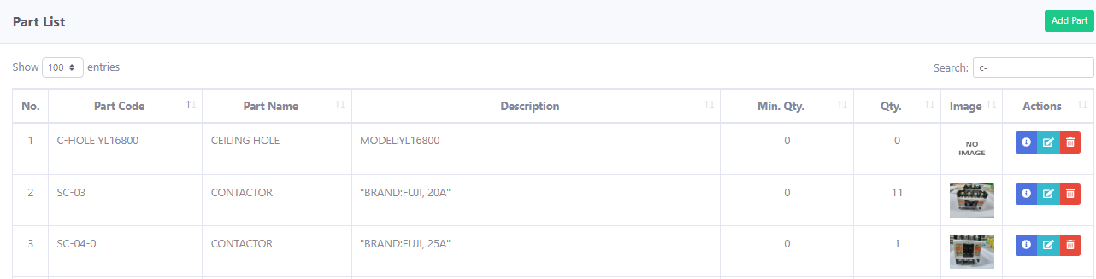

* The user can delete part information by clicking the trash button.

1. Report

* This function allows to view in/out/transfer, inventory and log from the system.
  1. In/Out

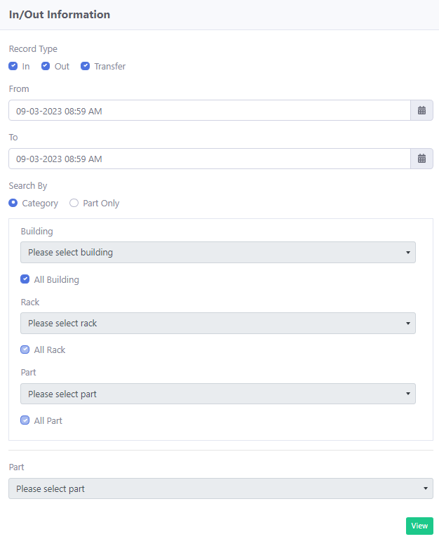

* The user can view in/out information by clicking the view button.
* Note:
* Allowed to search by part only if only remember part no. or part name.
  1. Inventory

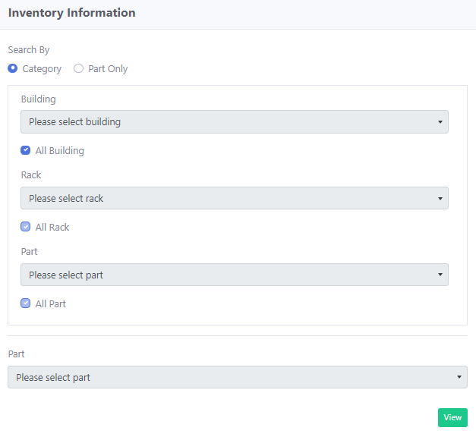

* The user can view inventory information by clicking the view button.
* Note:
* Allowed to search by part only if only remember part no. or part name.
  1. Log

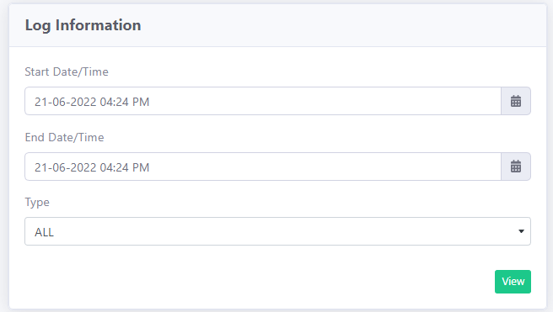

* The user can view log information by clicking the view button.
* Note:
* End date time cannot be less than start date time.

1. In/Out Record

* This function allows to record parts in/out/transfer and import parts by batch from the system.
  1. Record
     1. Type – In or Out or Transfer

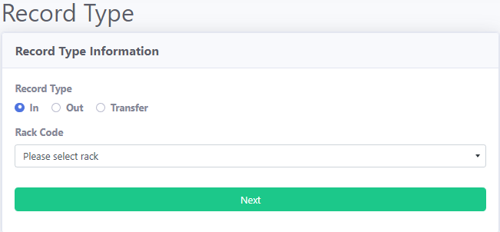

* The user can choose either in or out or transfer type of record.
* Note:
* Rack availability will be based on the registered rack in maintenance.
  + 1. Save Information

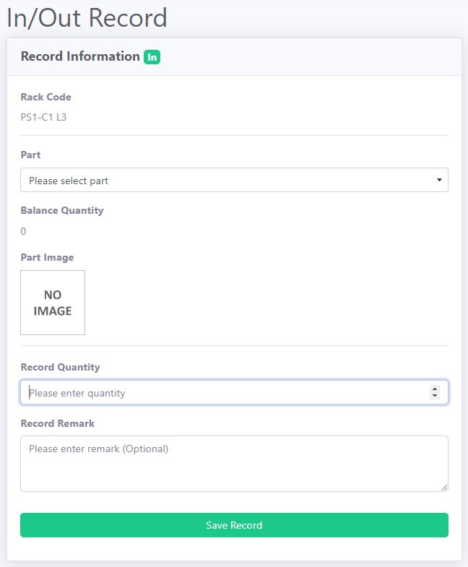

* Save the information by selecting the right part and record quantity.
* Note:
* Part image and balance quantity will display based on the part selection.
* Image displayed is based on the saved image at the part maintenance.
  1. Import

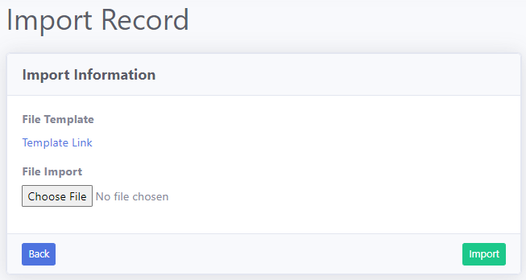

* Choose the selected file after finish update the template file.
* Note:
* Download template file at the link given for upload batch file.
* System will not update balance part quantity when part quantity exists in the system.